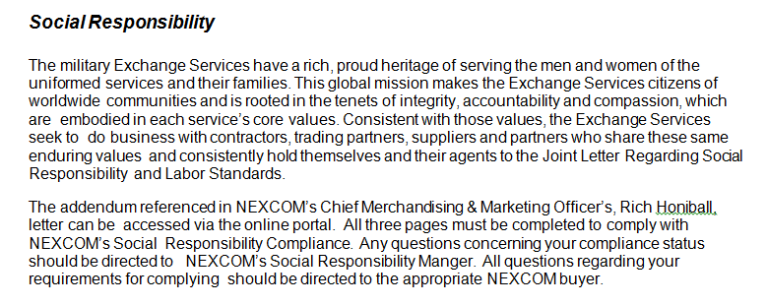
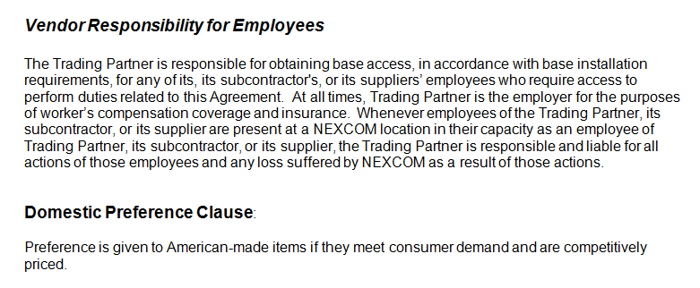
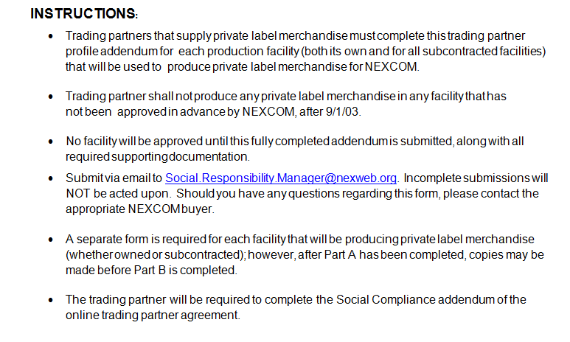
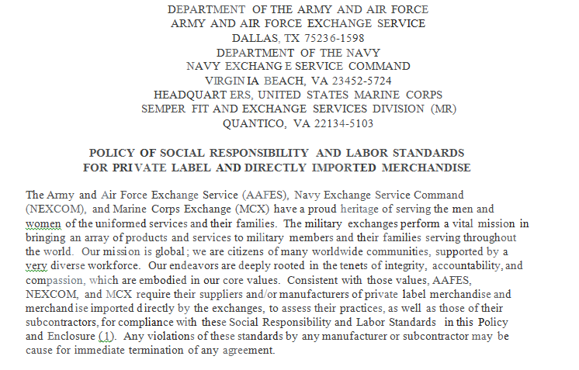
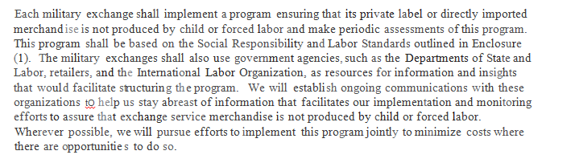
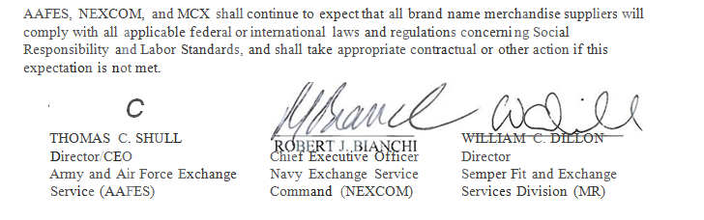

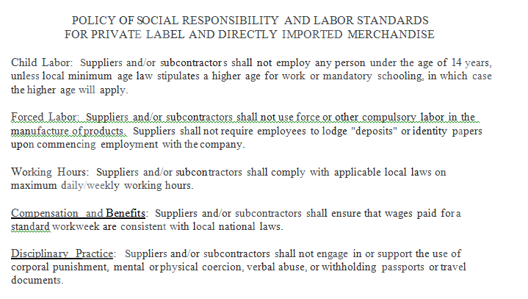

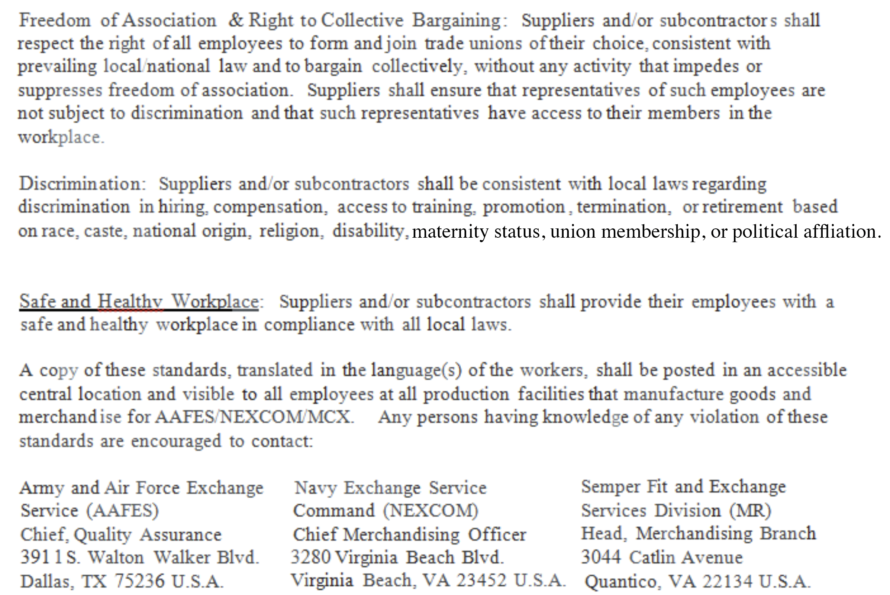
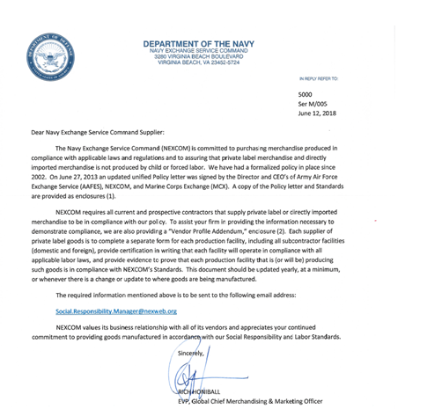

Executive Order 14173, Ending Illegal Discrimination and Restoring Merit-Based Opportunity, of January 21, 2025, rescinded Executive Order 11246 and directed formation and implementation of new Federal policy respecting Equal Employment Opportunity in Federal contracts. NEXCOM intends to update or remove related clauses pending receipt of implementing guidance, and will not seek to enforce them in the meantime.
Whenever conflict exists between a provision of Publication No. 61 and the terms of this contract, the terms of this contract shall govern.

