SEAVIN INC. VOLUNTARILY RECALLS SELECT BOTTLES OF LAKERIDGE AND SAN SEBASTIAN WINES
Seavin Incorporated (“Seavin”), doing business as Lakeridge Winery and Vineyards and also as San Sebastian Winery, announced a voluntary recall of select packages (Lakeridge Winery Southern Red, Southern White, and Cabernet Sauvignon, and San Sebastian Winery Vintners Red and Vintners White) containing 750 milliliter glass bottles of its wines which may contain small grains or bits of glass. The presence of small bits of glass in a wine bottle could pose a health risk to the consumer under certain circumstances. While the possibility of injury to an individual consumer is very low, people who bite or swallow a glass fragment possibly could incur injury.
The precautionary recall comes after the third-party manufacturer of Seavin’s wine bottles, Owens International, concluded testing related to its production methods. That testing focused on a manufacturing defect impacting glass bottles utilized by Seavin in certain Lakeridge and San Sebastian production runs.
A representative of Owens International involved in the investigation of the defective bottles indicated to Seavin that the number of bottles from its plant actually containing pieces of glass is numerically insignificant, and that the risk to the public is extremely small. Nevertheless, Seavin is voluntarily recalling certain of its Lakeridge and San Sebastian wines in the quantities identified below in an abundance of caution, to safeguard its consumers and the public at large.
Consumers who have purchased Lakeridge and/or San Sebastian wines in the bottles identified below are being advised not to drink the wine, and to dispose of the product. Seavin will issue a full refund on potentially affected product with reasonable proof of purchase. Seavin has received no reports of any consumer injury associated with the wines subject to this voluntary recall.
Affected Product:
Seavin Incorporated (“Seavin”)/Lakeridge Winery and Vineyards/San Sebastian Winery (Size 750 milliliter glass bottles)
Product Name | UPC | Manufacturing Code Date
San Sebastian Castillo Red | 8483340310 | 052317-2
Lakeridge Southern Red | 8483313510 | 030117 030217 030617 030717 030917 031317 031417 031517 042617 042617-2 052417
San Sebastian Vintners Red | 8483343110 | 022117 022217 022317 022717 022817 031517-2 041917-2 070617
San Sebastian Vintners White | 8483341110 | 030817-2 033017 040617 053117
Lakeridge Southern White | 8483311510 | 030817 032817 032917
Lakeridge Cabernet Sauvignon | 8483318210 | 052317

Scheid Vineyards California, Inc. is recalling the below product from Seavin, Inc. d/b/a Lakeridge Winery & Vineyards distributed by Scheid Vineyards. (Size 750 milliliter glass bottles)
Product Name | Lot Number or ID | Expiration/Use By Date
San Sebastian Vintners Red | 022117 | 2022-01-01

For any other questions or concerns regarding the Seavin, Inc. d/b/a Lakeridge Winery & Vineyards recall, please call 1-800-476-8463 seven days a week from 9:00 AM – 9:00 PM Eastern Time. Company's Voluntary Recall Webpage http://voluntaryrecallinfo.seavin.com.
For information or question regarding the Scheid Vineyards California, Inc. recall, please call Winemaker Shane Green (831) 970-8746.
Photos/Labeling Information:
Wine Bottle Date Code Location
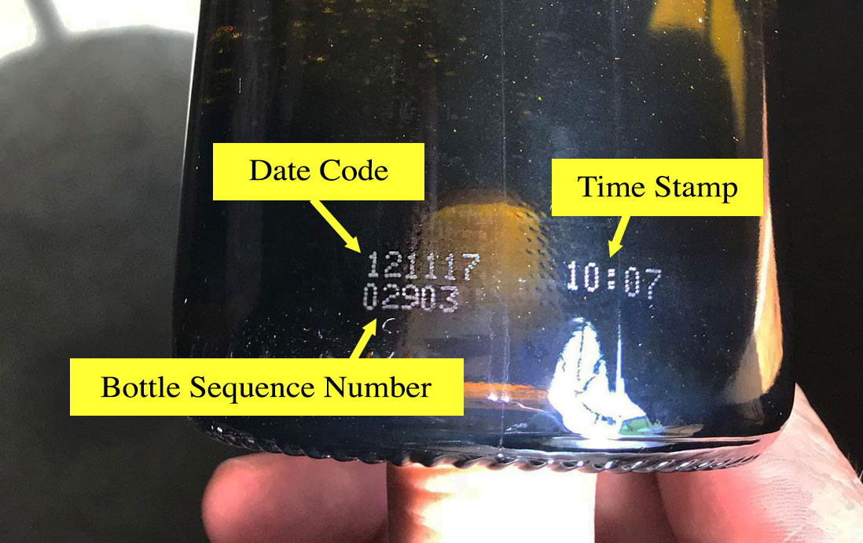
Due to the nature of the dark bottles the information shown in the photo can be difficult to read. It is very helpful to hold the bottle in very bright light such as direct sun light. The information will be found on the bottom 1” of the bottle and will appear in the exact format that you see in this image.

Wine Case Date Code Location
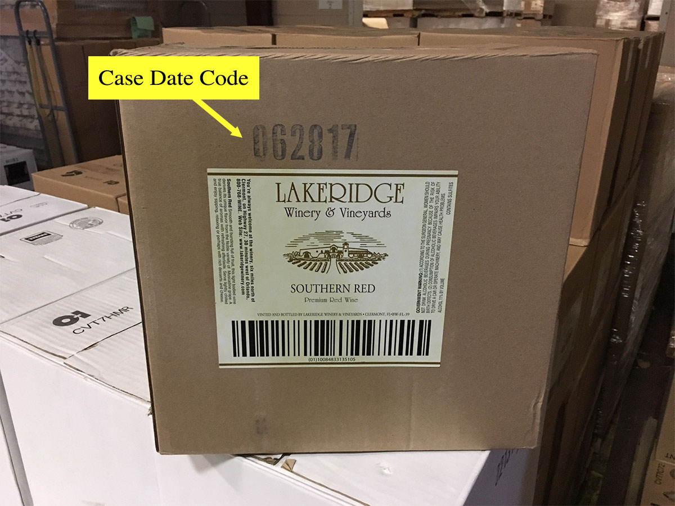
The code date on the outside of the case is much easier to read and can be found above or below the box label. If the label is no long in place simply look at all four sides of the box and it will appear on one of the sides.
Photos/labels not provided for the Scheid Vineyards California, Inc. recall product (San Sebastian Vintners Red).

